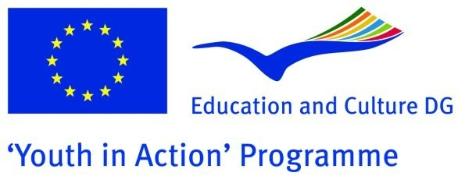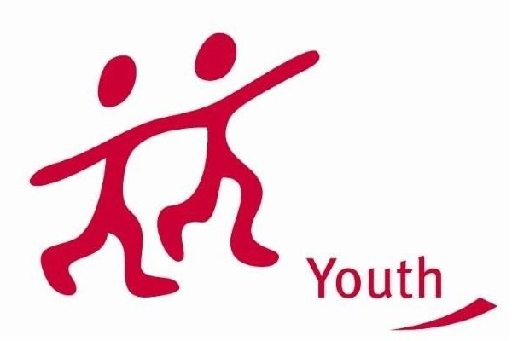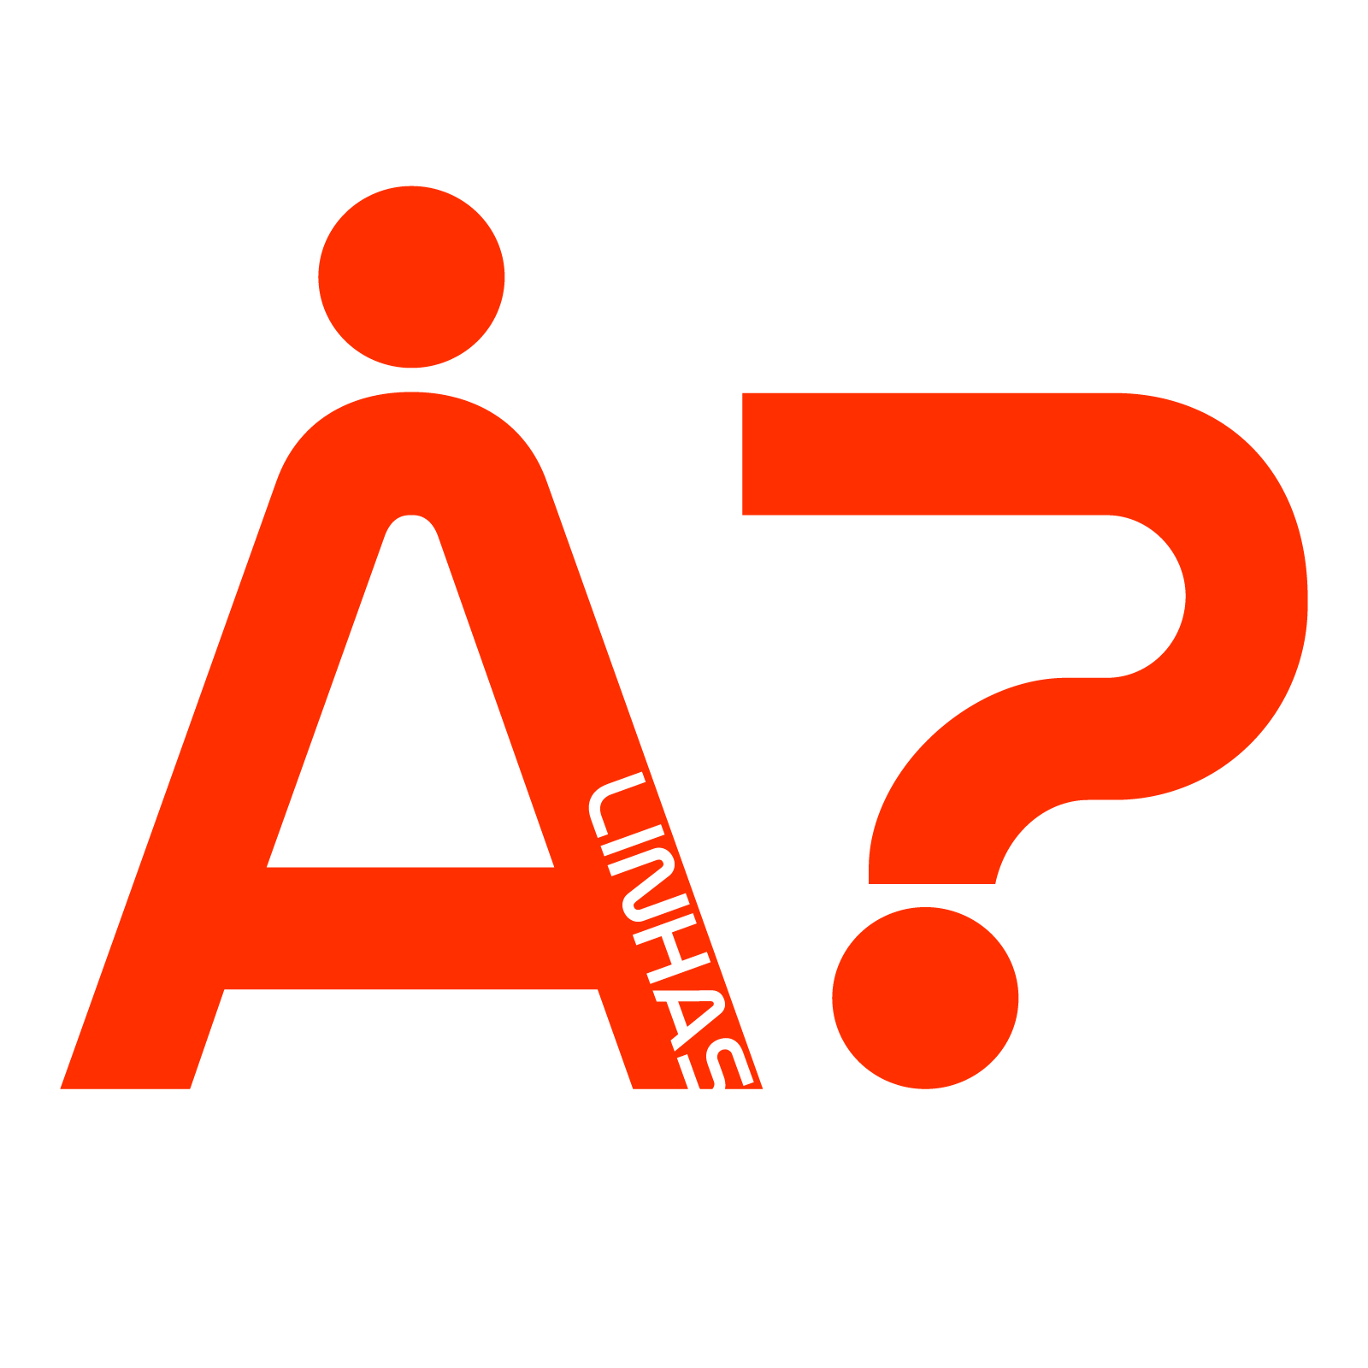

  - [action 3.1 training course]

[WHAT ABOUT GENDER]

Dear friends,
“Alinhas?”, a youth association from Portugal, would like to invite you to participate in a new project to be presented on the 1st of May deadline.
It is a training course that will explore different Gender issues affecting our countries and European society at large. Here you can check more about us and the project.
If you’re interested in participating in this project please fill and the required documentation and send it to us before the established deadline ;)

About ALINHAS
“ALINHAS?” started as a youth sports organization seeking to organize free sports activities, thus providing the society at large with the possibility of practicing various sports and participating in several socio-cultural initiatives.
Nowadays, it has broadened its horizons and counts within its ranks with a multidisciplinary team of young people motivated by the goal of encouraging transnational cooperation in the youth field through projects such as this one in order to support personal and professional development of young people and to promote active participation for common democratic values.

About the Project
“What about Gender?” is a Training Course that will be realized in Porto, Portugal and gather young people and youth workers from different European countries to discuss different subjects connected to the topic of Gender.
During one week the participants will have the chance to discover Gender issues through non-formal methods such as debates, simulations, role-playing, interviews, group work, presentations or games. This way we intend to actively involve the participants in the diverse working moments, sharing opinions, cooperating amongst themselves, learning from each other and ultimately conceiving project ideas together.
Moreover, it will be possible to better understand the way how subjects such as gender equality, sexual-based discrimination, homosexuality or the role of women are perceived and treated in our countries and in the European space in general. Indeed, it will create a space for discussion between the participants but also to explore the features of the European Strategy for equality between women and men 2010-2015 and strive to discover what can and shall be done in order raise awareness for the importance of the conflict-ridden topic of gender equality and gender stereotypes.
So, we expect to generate an experience of great personal and professional growth with significant development of skills and competences that promote and facilitate the preparation and realization of projects and activities about Gender Discrimination – at international or local level – by providing examples of the tools as well as the methods which may be used for the development of such projects.
OTHER DETAILS
Dates: 13 - 21 October 2012
Location: Porto, Portugal
Participation fee: €20
Target: Young people, youth leaders, youth workers, human rights activists [18⁺]
Countries: EU member countries, Programme countries, SEE Countries, EECA countries
Number of participants: 10 (3 per country)

If you are interested in participating please send the Partner Identification form in attachment to ricardo.neves@alinhas.pt before the 20th April 2012.

Kind regards,
Ricardo Neves

