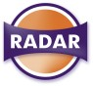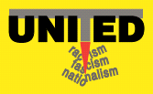
Pre application form
International training: Your Power, Our Power
Empowerment as means to promote active citizenship and inclusive societies
Five-day training
Dates training: 2-7 September 2012
Location: Rotterdam, the Netherlands
Deadline application: 6 April 2012

Personal

First name:

Family name:

Gender: () M () F

Age:

Adress:

E-mail address:

Phone:

Function:

Organization (if applicable)

Name:

Name in English:

Address:

Phone:

Website:

E-mail:

Background information

- Describe your organisation (if applicable):

- What is your current function or profession?:

- Are you in your work involved in the planning or delivery of training, or of awareness raising activities? If yes give some examples:

- Do you have experience with empowerment training and/or projects?:

- Describe your training needs and explain how the training activity you have selected matches your training needs.

- Describe the expected impact of the proposed training on your personal and professional competences:

- In what way you hope to use what you will learn in this training?:

